**CURRENCY CONVERTER**

Project submitted to the

SRM University – AP, Andhra Pradesh

for the partial fulfillment of the requirements to award the degree of

**Bachelor of Technology**

In

**Computer Science and Engineering**

**School of Engineering and Sciences**

Submitted by

**Y ABHIRAM---AP21110010373**

**KODURI C S N V SATYANARAYANA---AP21110011199**

**T NIKHIL---AP21110011200**



Under the Guidance of

**K.JYOTHSNA DEVI**

**SRM University–AP**

**Neerukonda, Mangalagiri, Guntur**

**Andhra Pradesh – 522 502**

# AIM

The aim of the project is to convert amount from one currency to another currency and you can choose different currencies and enter a value in one currency to be convert into other selected currencies. The primary goal of a currency converter is to accurately and quickly provide the equivalent value. The project is a helpful tool for people who need to quickly convert currencies for travel, or personal reasons.

# OBJECTIVES

* Enable quick and easy currency conversions.
* Support multiple currencies.
* User friendly interface.
* Provide accurate exchange rates.

# INTRODUCTION

A currency converter project is a tool that you convert the value of one currency into another currency, with a currency converter, you can easily find out how much your money is worth in a different currency. It's useful when you're traveling to another country or when you're making international purchases. The currency converter project aims to provide a user-friendly interface where you can enter the amount you want to convert and select the currencies involved. It then gives you an accurate conversion based on the exchange rates. The goal of the project is to make currency conversions quick, easy, and reliable for users.

# SYSTEM REQUIREMENTS

# HARDWARE REQUIREMENTS

* RAM : At least 8 GB
* Disk Space : 124 MB for JRE, 2 MB for Java Update
* Processor : 11th Gen Intel(R) Core(TM) i5-1135G7 @ 2.40GHz 2.42 GHz.

# SOFTWARE REQUIREMENTS

* Eclipse IDE is a software that is used in development and execution of java programs.
* Eclipse Window Builder for using GUI application.

# MODULES

There are 2 modules in the Project

1. Interface
2. Currency Exchange Rates

The role of interface:

* User friendly interface it can easily access by anyone.
* JLabel: displays text labels (Amount, Result, convert from, convert to)
* JTextField: a text field where the user can enter the amount to convert.
* JComboBox: a drop-down list for selecting the currency to convert from and to.
* JTextArea: displays the result of the conversion.
* JButton: a button to convert currency.

The role of currency exchange rates:

* Added currencies of (USD, INR, EUR, JPY, RUB, GBP)
* In this we will provide the exchange rates.
* getExchangeRate(): a method that fetches the exchange rate for the selected currencies.

**CODE&RESULTS**

**package** currencyconverter;

**import** java.awt.*;

**import** javax.swing.*;

**import** javax.swing.border.EmptyBorder;

**public** **class** Source **extends** JFrame {

**private** JPanel contentPane;

**private** JTextField txtamount;

/**

* Launch the application.

*/

**public** **static** **void** main(String[] args) {

EventQueue.*invokeLater*(**new** Runnable() {

**public** **void** run() {

**try** {

Source frame = **new** Source();

frame.setVisible(**true**);

} **catch** (Exception e) {

e.printStackTrace();

}

}

});

}

/**

* Create the frame.

*/

**public** Source() {

setDefaultCloseOperation(JFrame.***EXIT_ON_CLOSE***);

setBounds(100, 100, 450, 300);

contentPane = **new** JPanel();

contentPane.setBorder(**new** EmptyBorder(5, 5, 5, 5));

setContentPane(contentPane);

contentPane.setLayout(**null**);

JLabel from = **new** JLabel("convert from:");

from.setFont(**new** Font("Tahoma", Font.***PLAIN***, 17));

from.setBounds(24, 63, 133, 28);

contentPane.add(from);

JLabel to = **new** JLabel("convert to:");

to.setFont(**new** Font("Tahoma", Font.***PLAIN***, 17));

to.setBounds(24, 147, 133, 28);

contentPane.add(to);

txtamount = **new** JTextField();

txtamount.setBounds(133, 25, 171, 28);

contentPane.add(txtamount);

txtamount.setColumns(10);

JLabel amount = **new** JLabel("Amount:");

amount.setFont(**new** Font("Tahoma", Font.***PLAIN***, 16));

amount.setBounds(24, 28, 85, 25);

contentPane.add(amount);

JComboBox<String> from_convert = **new** JComboBox<String>();

from_convert.setModel(**new** DefaultComboBoxModel<String>(**new** String[] {"USD", "INR", "EUR", "JPY","RUB","GBP"}));

from_convert.setBounds(143, 70, 217, 28);

contentPane.add(from_convert);

JComboBox<String> to_convert = **new** JComboBox<String>();

to_convert.setModel(**new** DefaultComboBoxModel<String>(**new** String[] {"USD", "INR", "EUR", "JPY","RUB","GBP"}));

to_convert.setBounds(143, 147, 217, 28);

contentPane.add(to_convert);

JButton convert = **new** JButton("convert");

convert.setFont(**new** Font("Tahoma", Font.***PLAIN***, 15));

convert.setBounds(156, 232, 85, 21);

contentPane.add(convert);

JTextArea txtResult = **new** JTextArea();

txtResult.setBounds(84, 196, 300, 22);

contentPane.add(txtResult);

JLabel r = **new** JLabel("result:");

r.setFont(**new** Font("Tahoma", Font.***PLAIN***, 15));

r.setBounds(24, 197, 64, 19);

contentPane.add(r);

convert.addActionListener(e -> {

**double** txtamountValue = Double.*parseDouble*(txtamount.getText());

String fromCurrency = from_convert.getSelectedItem().toString();

String toCurrency = to_convert.getSelectedItem().toString();

**double** rate = *getExchangeRate*(fromCurrency, toCurrency);

**double** result = txtamountValue * rate;

String resultText = txtamountValue + " " + fromCurrency + " = " + result + " " + toCurrency;

txtResult.setText(resultText);

});

}

**public** **static** **double** getExchangeRate(String fromCurrency, String toCurrency) {

**if** (fromCurrency.equals(toCurrency)) {

**return** 1;

} **else** **if** (fromCurrency.equals("USD") && toCurrency.equals("INR")) {

**return** 82.19;

} **else** **if** (fromCurrency.equals("USD") && toCurrency.equals("EUR")) {

**return** 0.92;

} **else** **if** (fromCurrency.equals("USD") && toCurrency.equals("JPY")) {

**return** 134.72;

} **else** **if** (fromCurrency.equals("USD") && toCurrency.equals("RUB")) {

**return** 76.86;

} **else** **if** (fromCurrency.equals("USD") && toCurrency.equals("GBP")) {

**return** 0.80;

} **else** **if** (fromCurrency.equals("INR") && toCurrency.equals("USD")) {

**return** 0.012;

} **else** **if** (fromCurrency.equals("INR") && toCurrency.equals("EUR")) {

**return** 0.011;

} **else** **if** (fromCurrency.equals("INR") && toCurrency.equals("JPY")) {

**return** 1.64;

} **else** **if** (fromCurrency.equals("INR") && toCurrency.equals("RUB")) {

**return** 0.94;

} **else** **if** (fromCurrency.equals("INR") && toCurrency.equals("GBP")) {

**return** 0.0097;

} **else** **if** (fromCurrency.equals("EUR") && toCurrency.equals("USD")) {

**return** 1.09;

} **else** **if** (fromCurrency.equals("EUR") && toCurrency.equals("INR")) {

**return** 89.78;

} **else** **if** (fromCurrency.equals("EUR") && toCurrency.equals("JPY")) {

**return** 147.17;

} **else** **if** (fromCurrency.equals("EUR") && toCurrency.equals("RUB")) {

**return** 83.98;

} **else** **if** (fromCurrency.equals("EUR") && toCurrency.equals("GBP")) {

**return** 0.87;

} **else** **if** (fromCurrency.equals("JPY") && toCurrency.equals("USD")) {

**return** 0.0074;

} **else** **if** (fromCurrency.equals("JPY") && toCurrency.equals("INR")) {

**return** 0.61;

} **else** **if** (fromCurrency.equals("JPY") && toCurrency.equals("EUR")) {

**return** 0.0068;

} **else** **if** (fromCurrency.equals("JPY") && toCurrency.equals("RUB")) {

**return** 0.57;

} **else** **if** (fromCurrency.equals("JPY") && toCurrency.equals("GBP")) {

**return** 0.0059;

} **else** **if** (fromCurrency.equals("RUB") && toCurrency.equals("USD")) {

**return** 0.013;

} **else** **if** (fromCurrency.equals("RUB") && toCurrency.equals("INR")) {

**return** 1.07;

} **else** **if** (fromCurrency.equals("RUB") && toCurrency.equals("EUR")) {

**return** 0.012;

} **else** **if** (fromCurrency.equals("RUB") && toCurrency.equals("JPY")) {

**return** 1.76;

} **else** **if** (fromCurrency.equals("RUB") && toCurrency.equals("GBP")) {

**return** 0.010;

} **else** **if** (fromCurrency.equals("GBP") && toCurrency.equals("USD")) {

**return** 1.25;

} **else** **if** (fromCurrency.equals("GBP") && toCurrency.equals("INR")) {

**return** 102.82;

} **else** **if** (fromCurrency.equals("GBP") && toCurrency.equals("EUR")) {

**return** 1.15;

} **else** **if** (fromCurrency.equals("GBP") && toCurrency.equals("JPY")) {

**return** 168.61;

} **else** **if** (fromCurrency.equals("GBP") && toCurrency.equals("RUB")) {

**return** 95.97;

} **else** {

**return** 0;

}

}

}

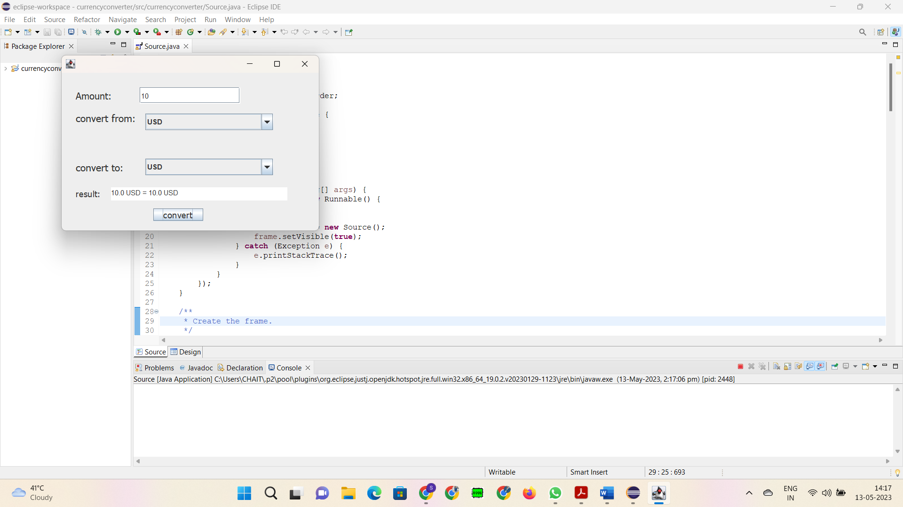 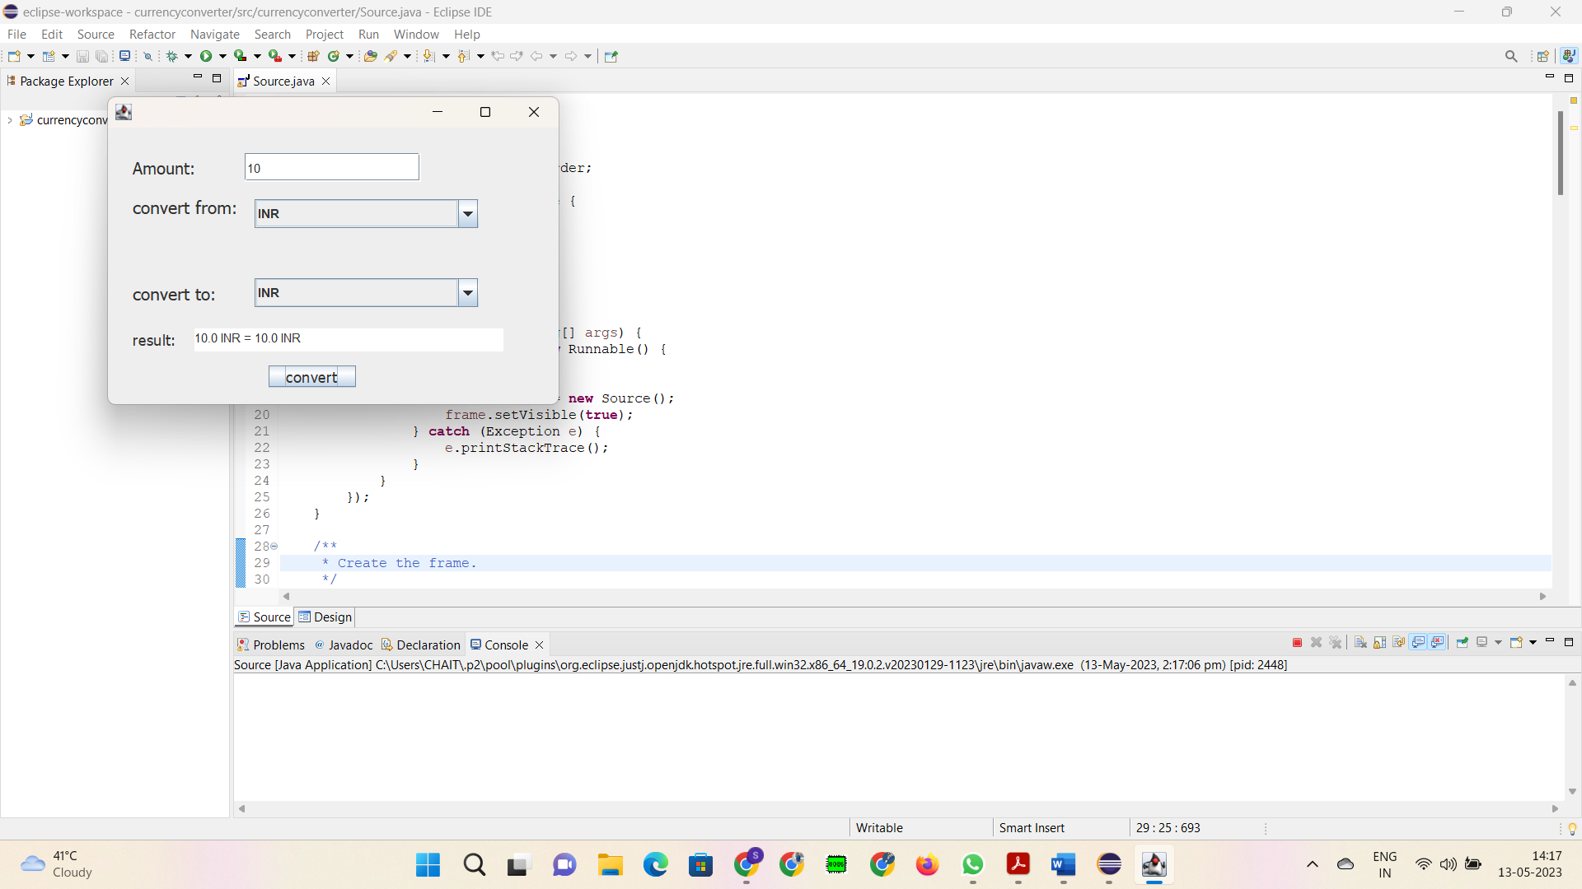 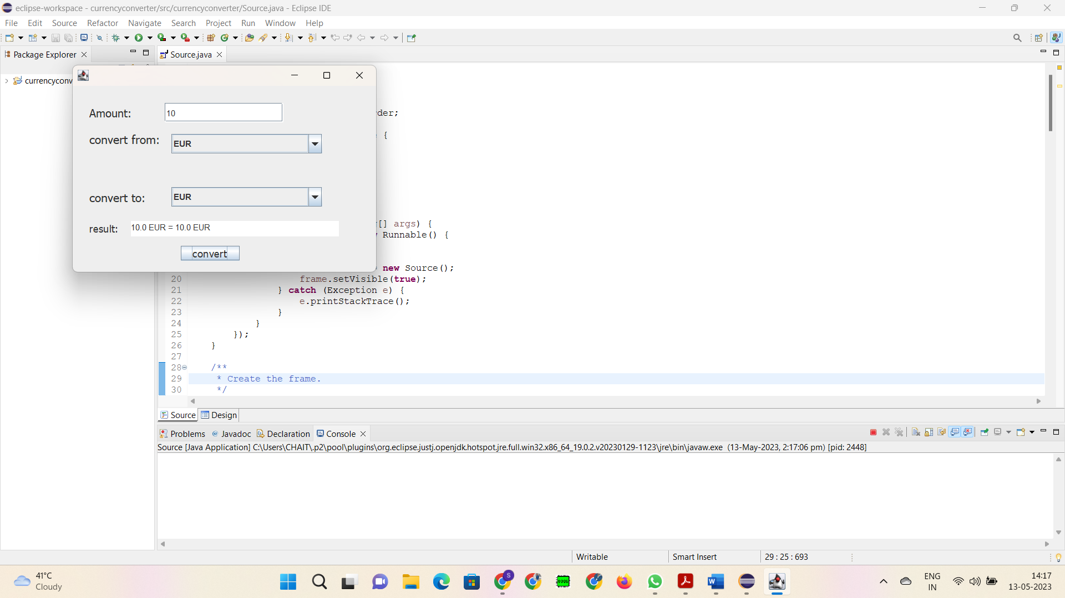

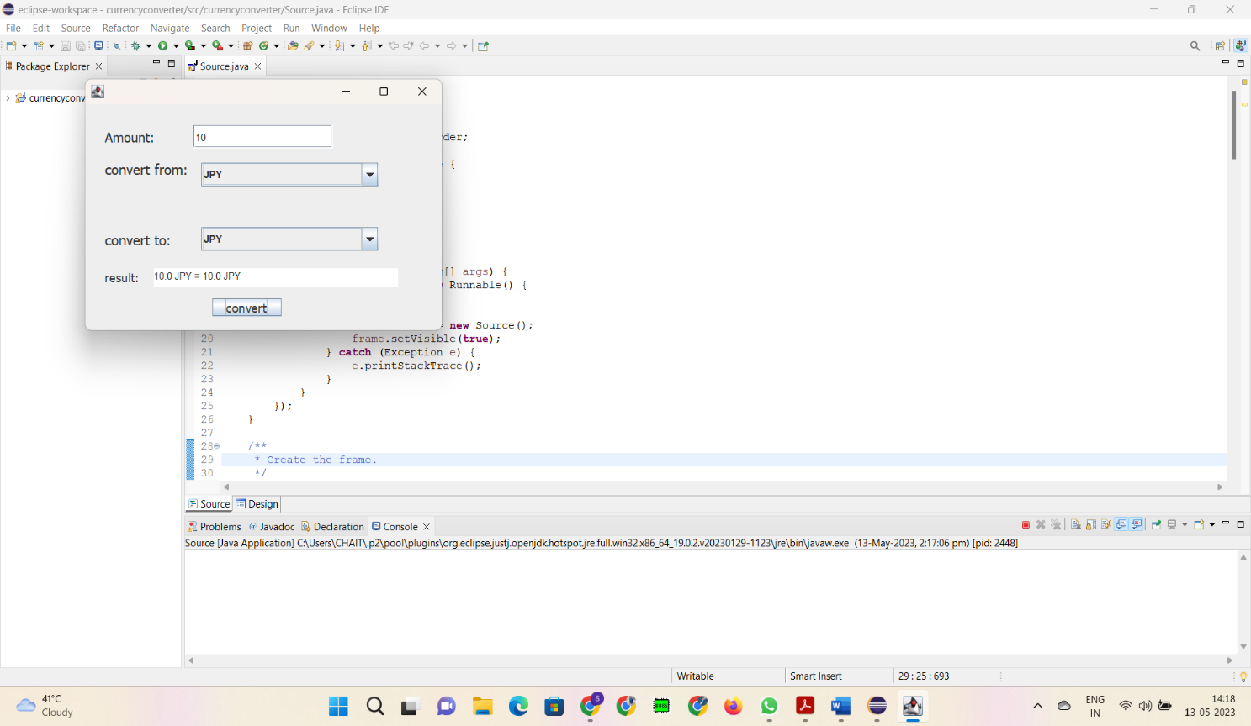 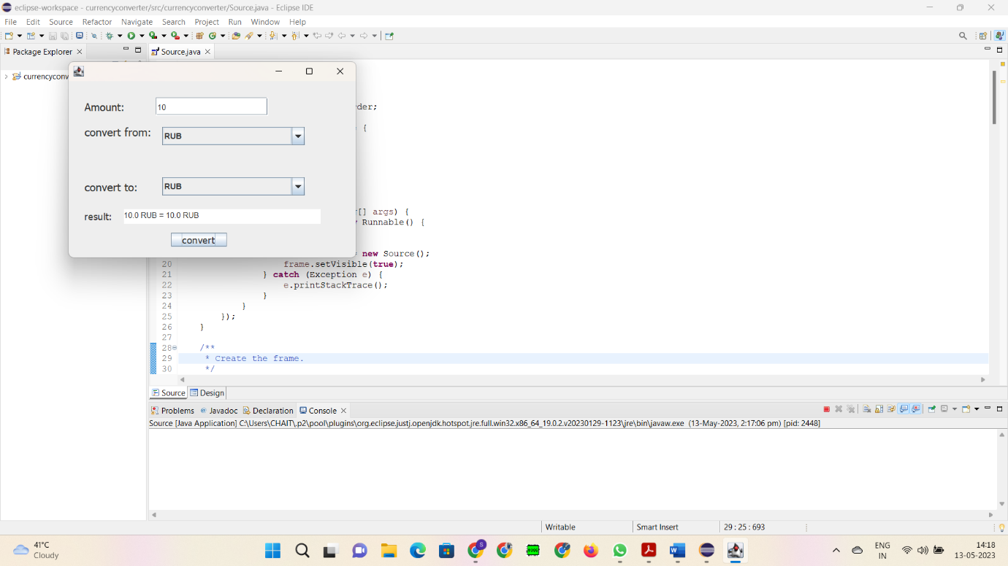 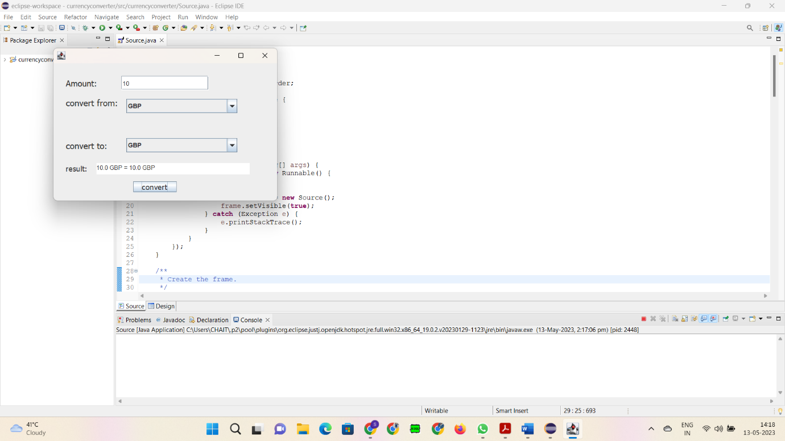

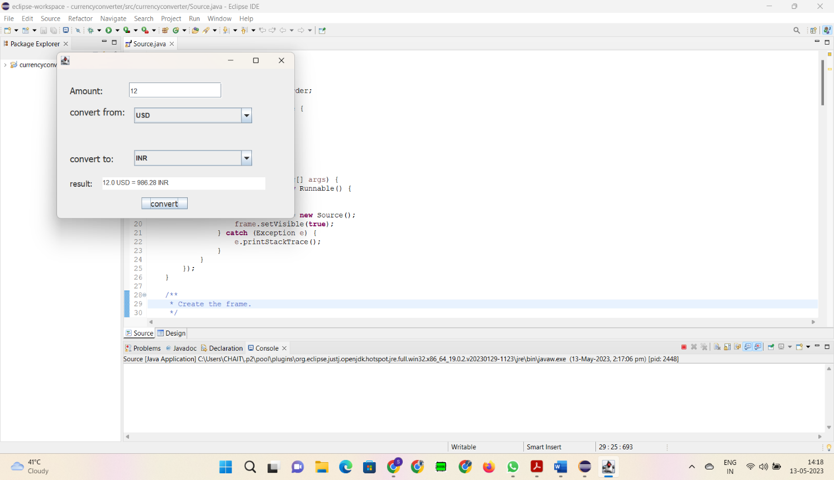 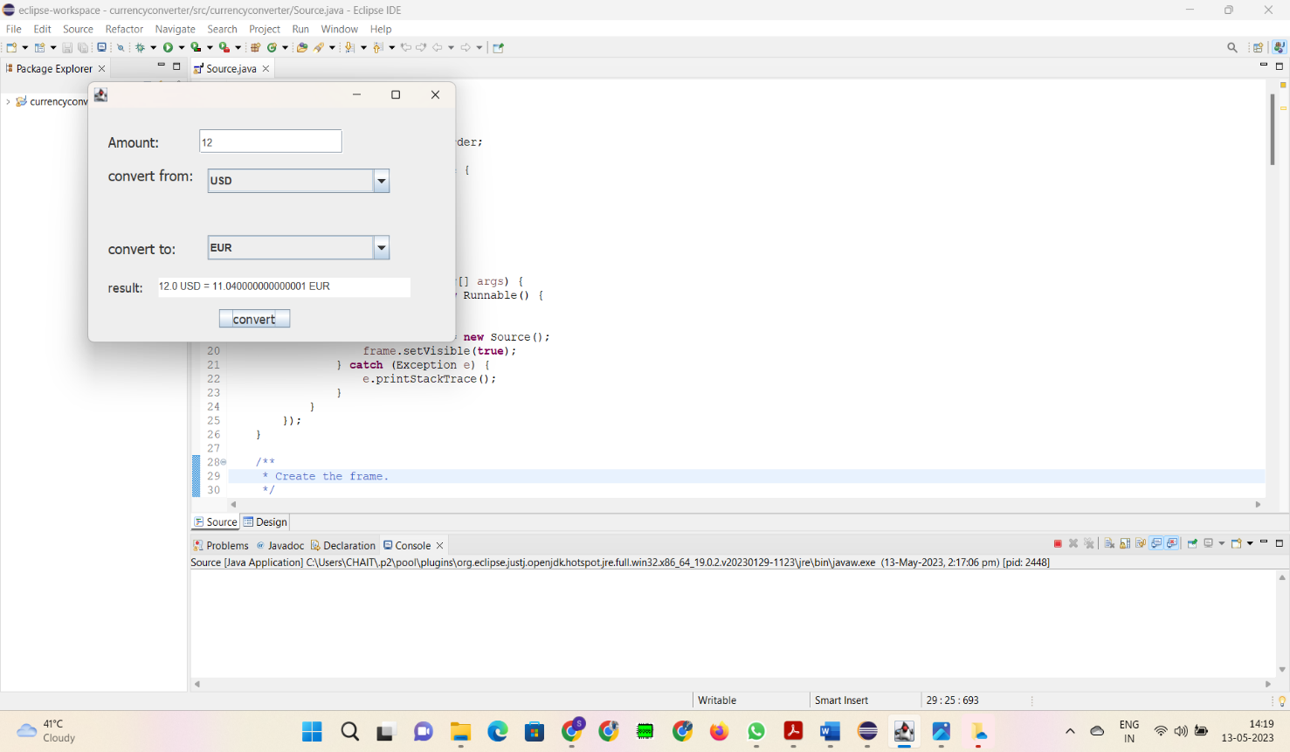 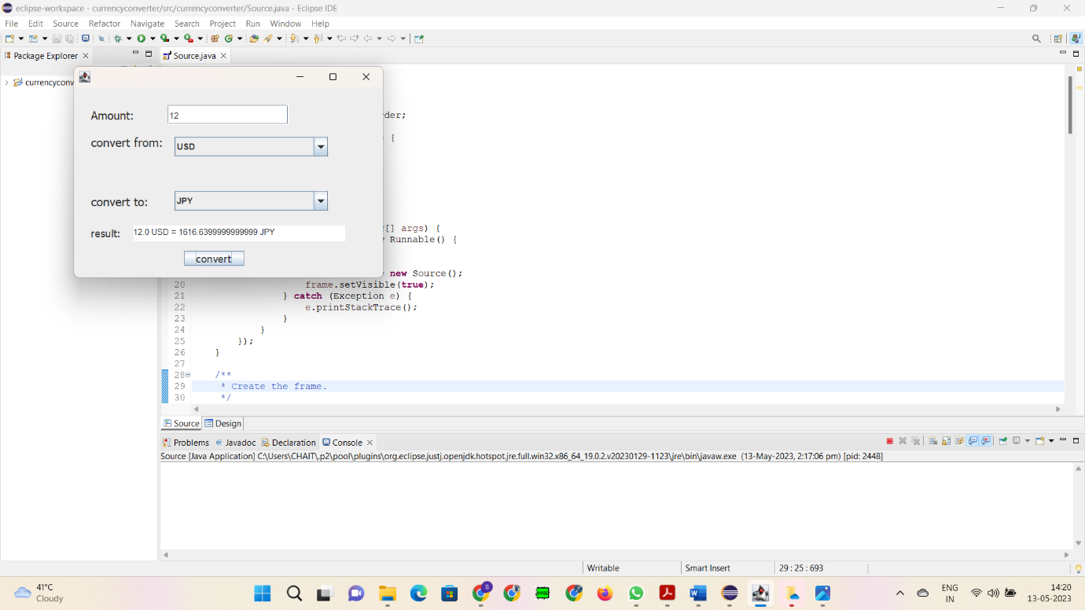

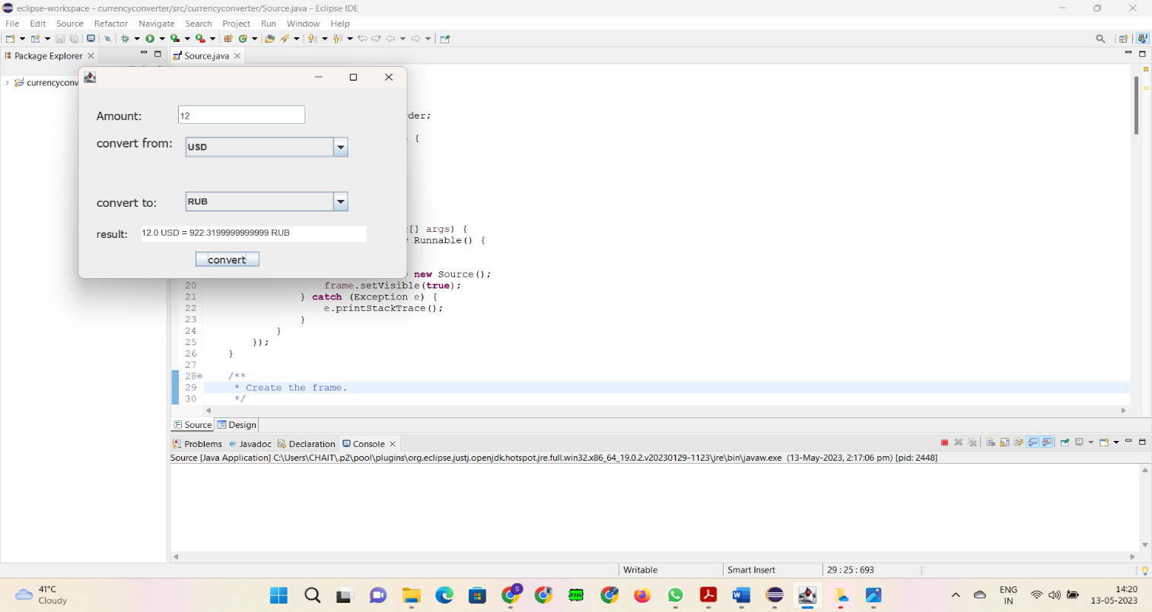 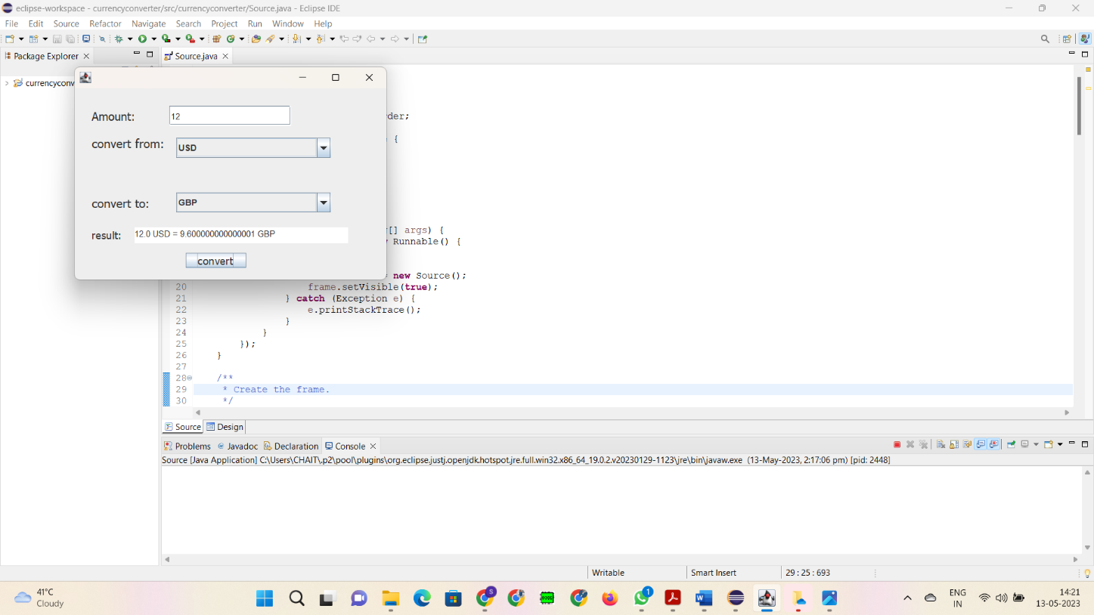 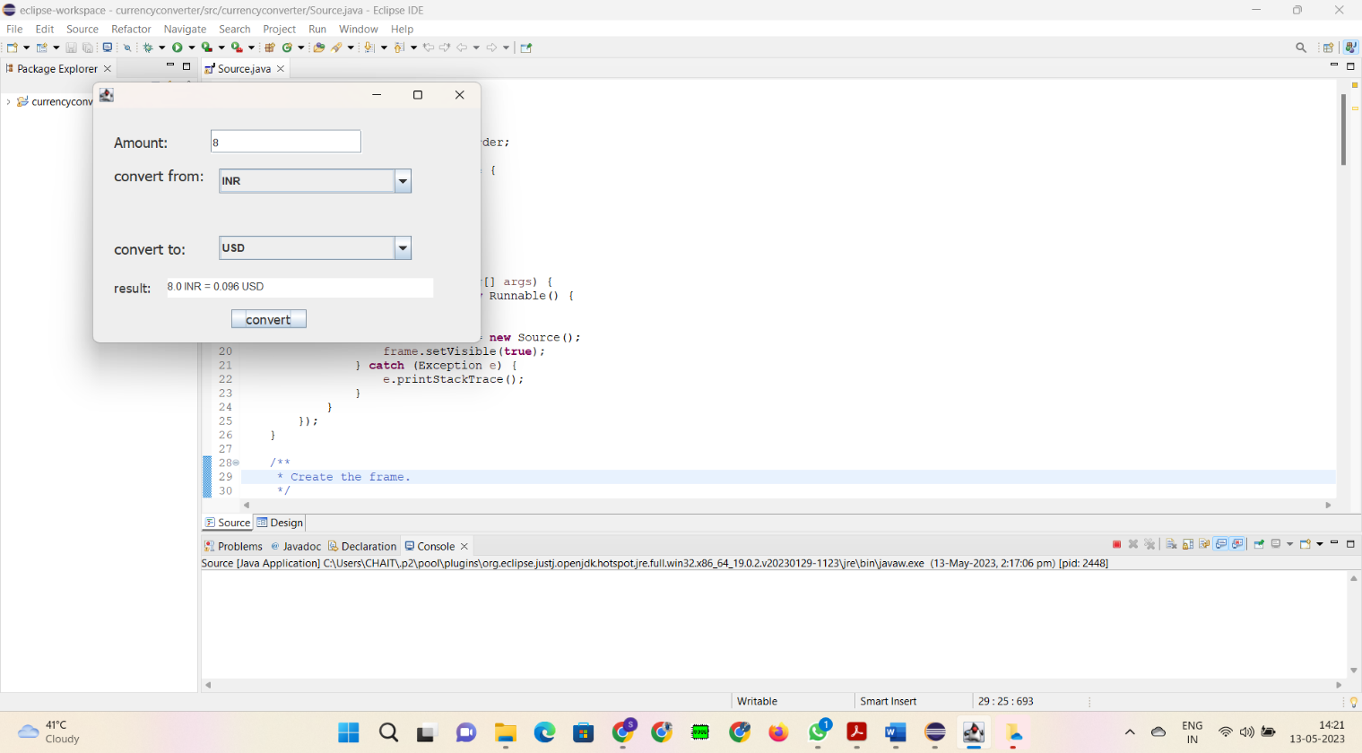

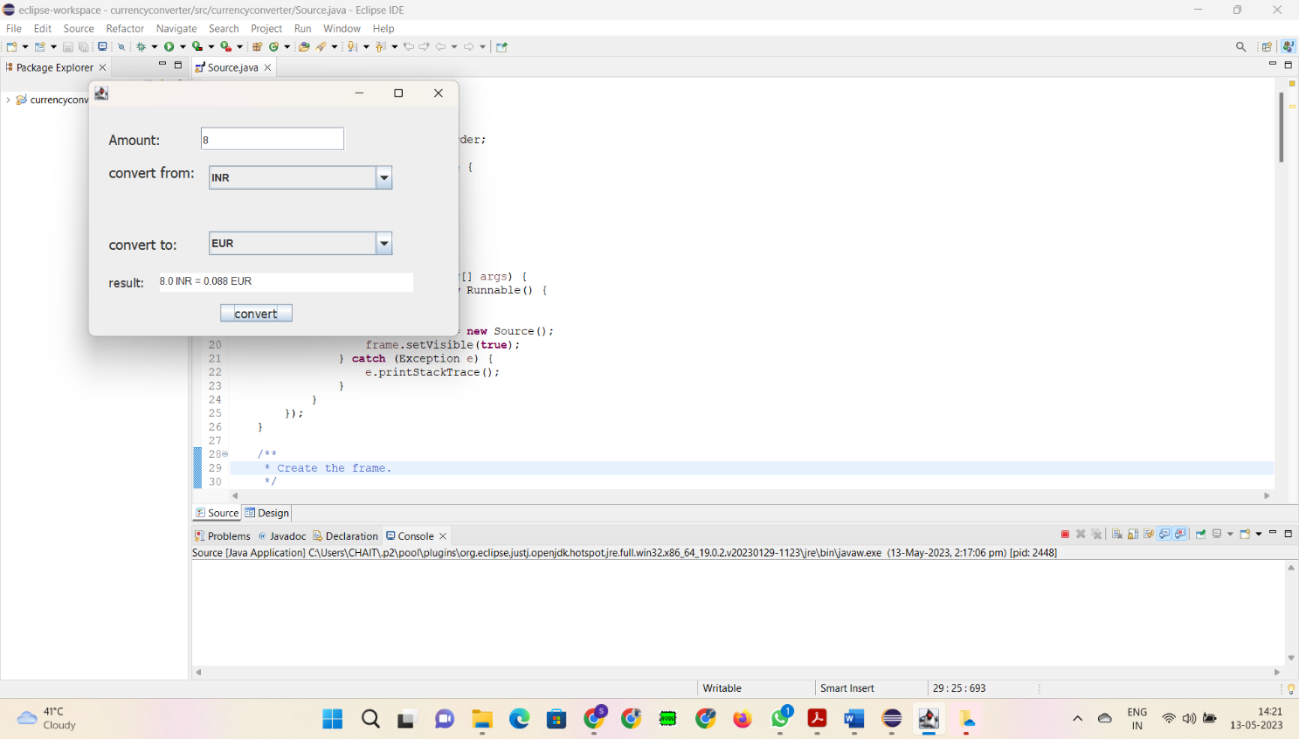 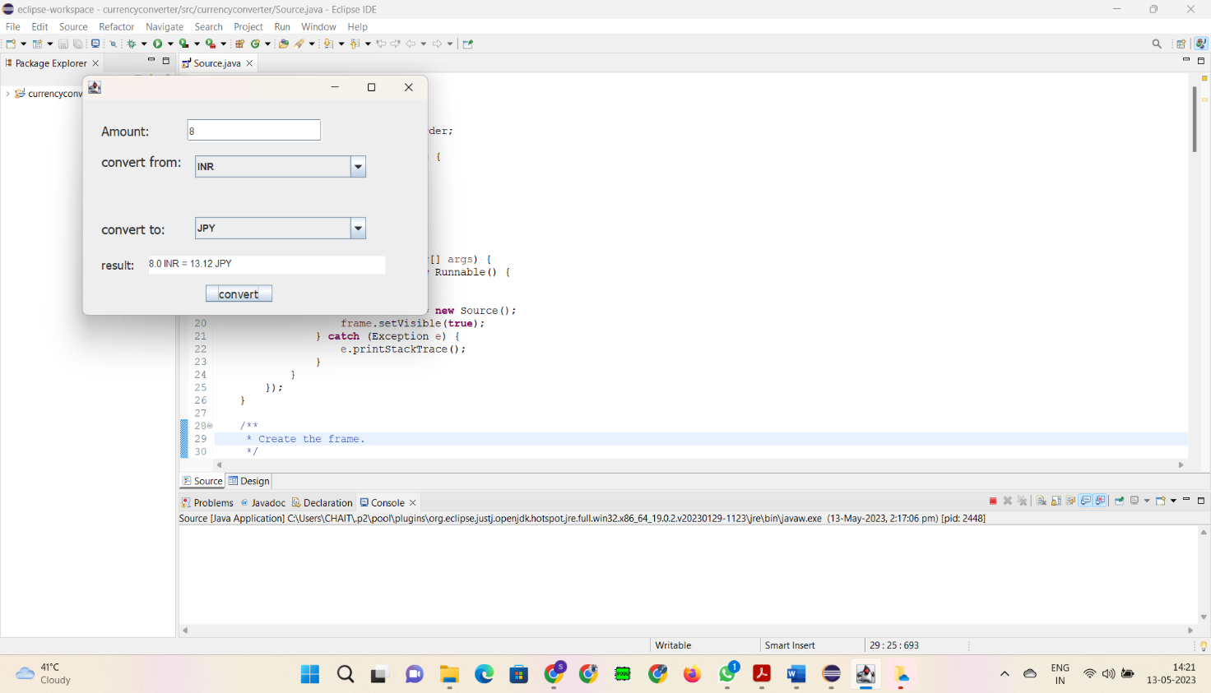 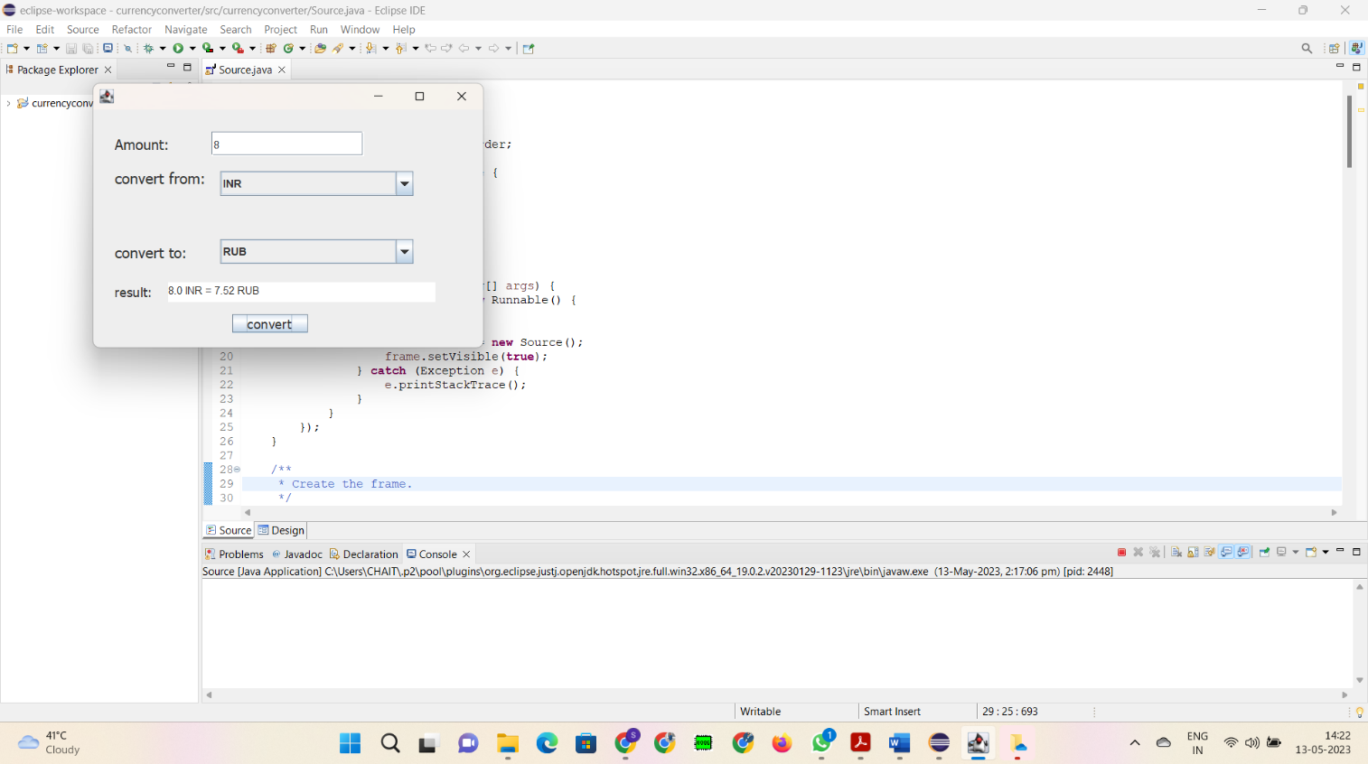

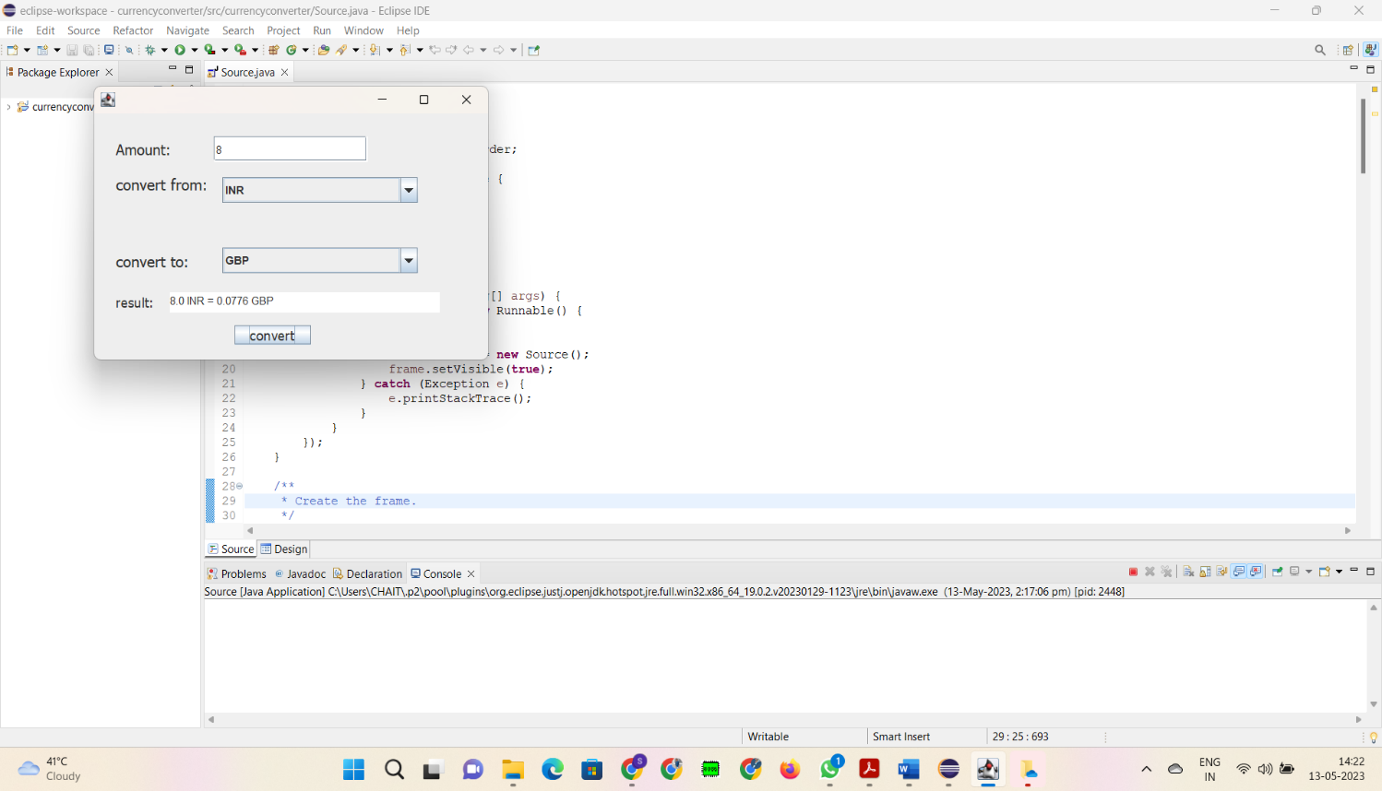 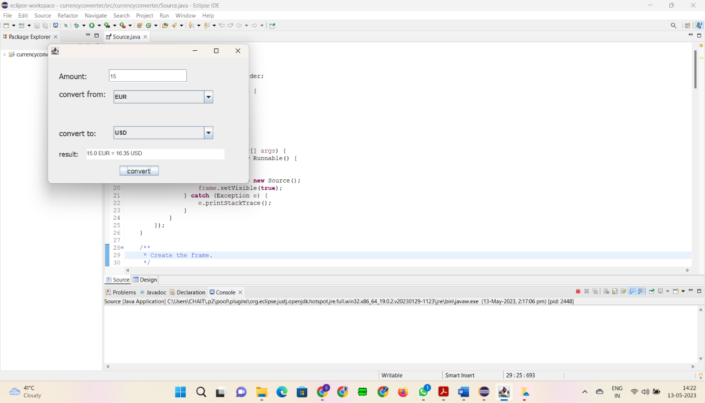 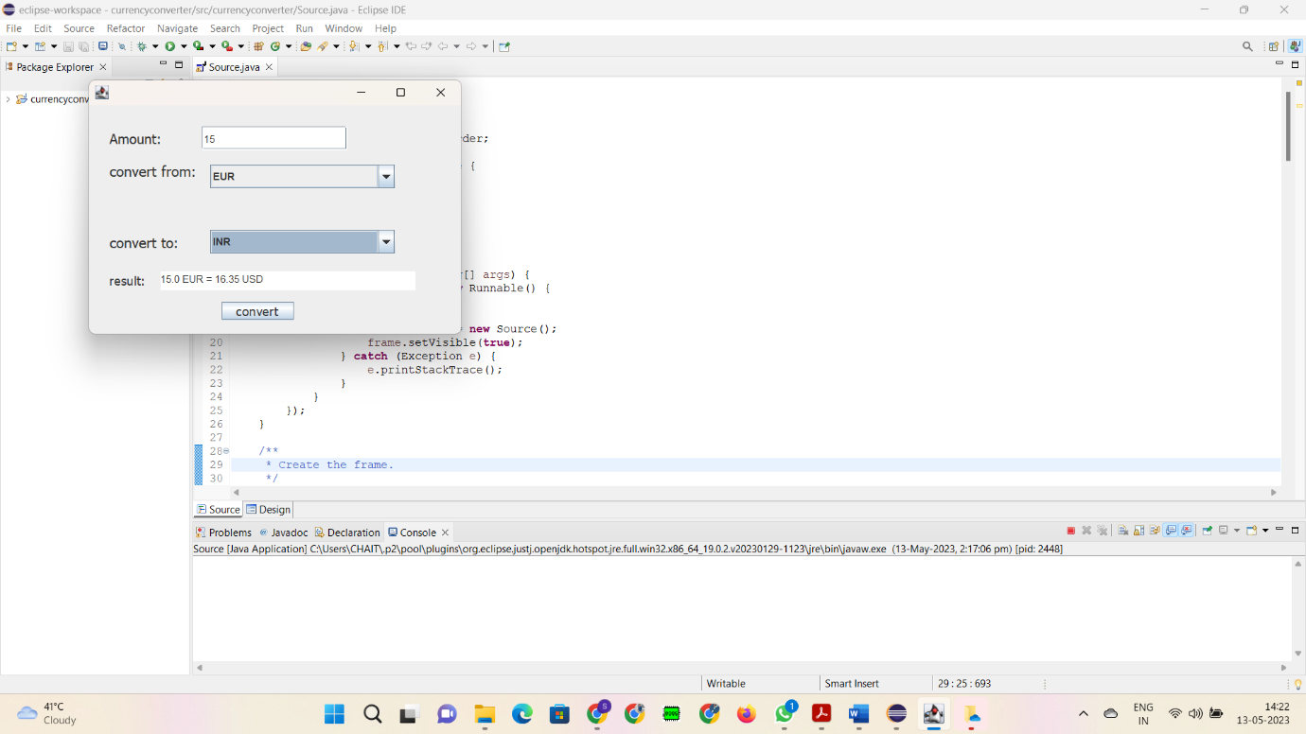

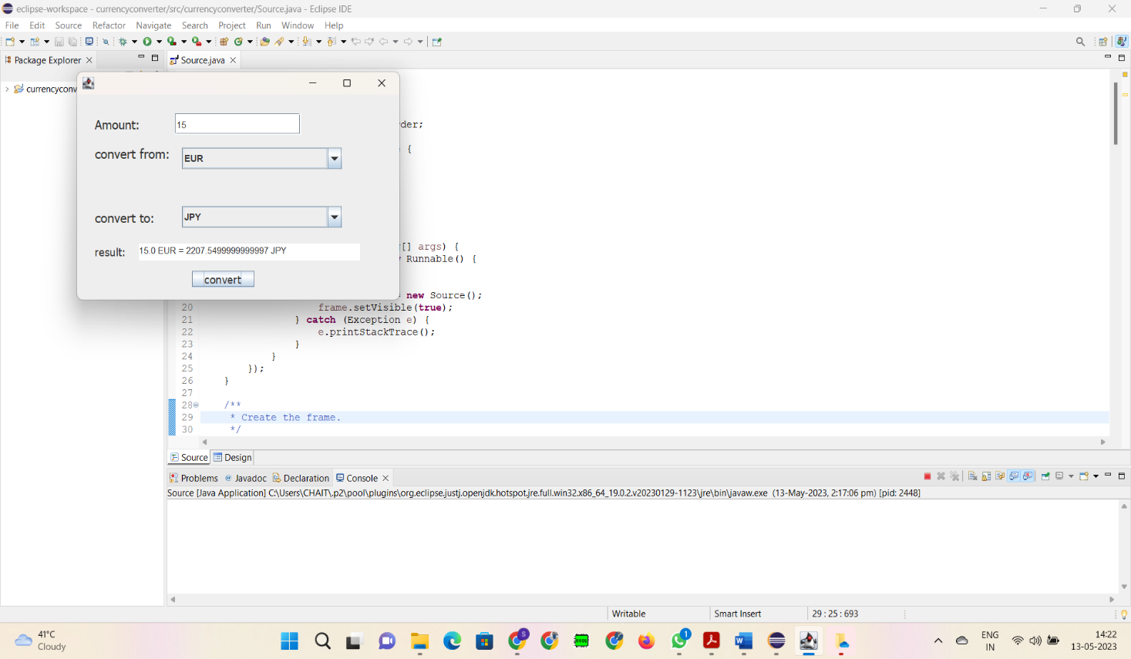 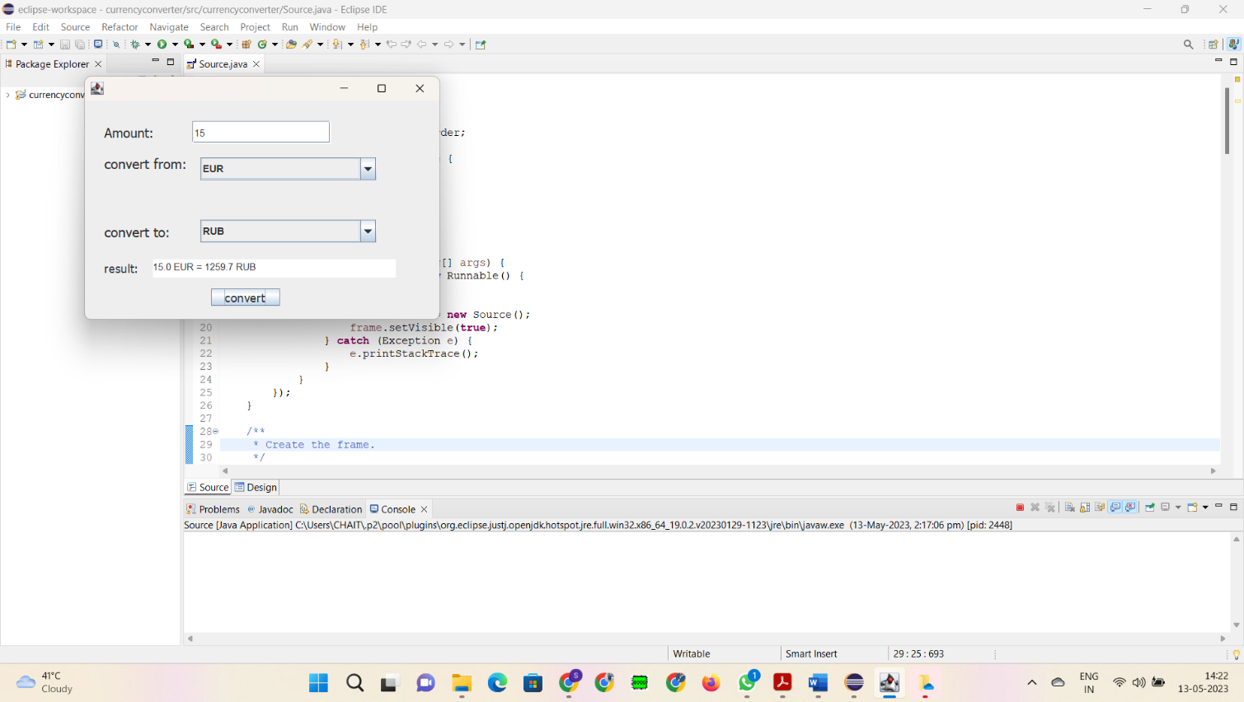 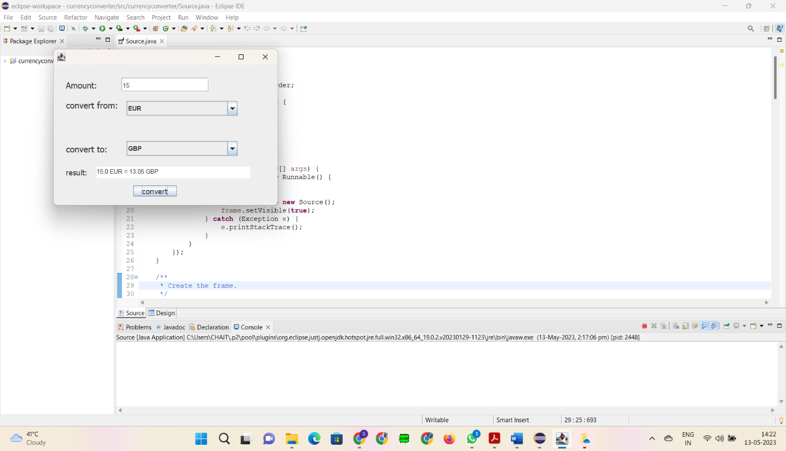

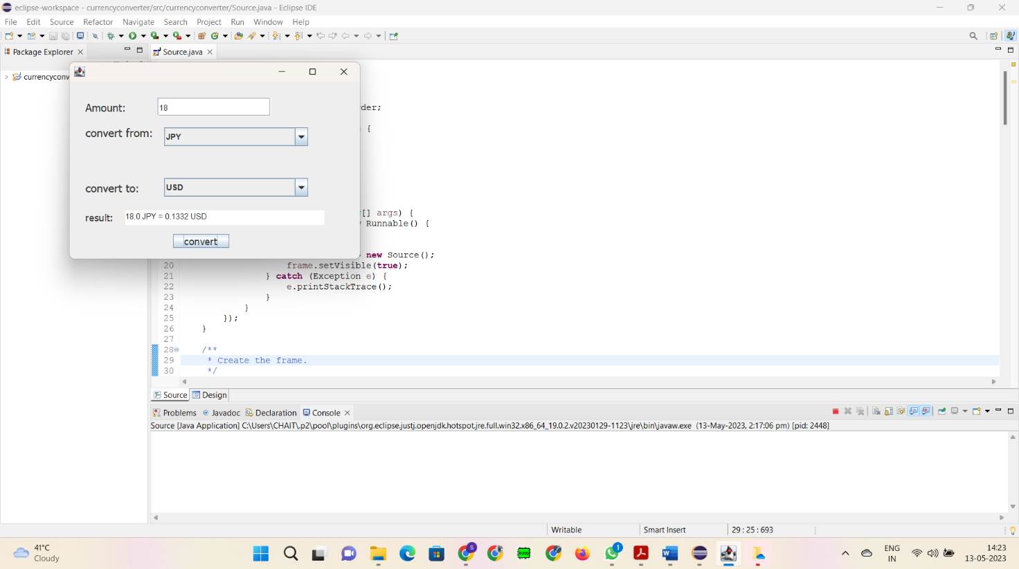 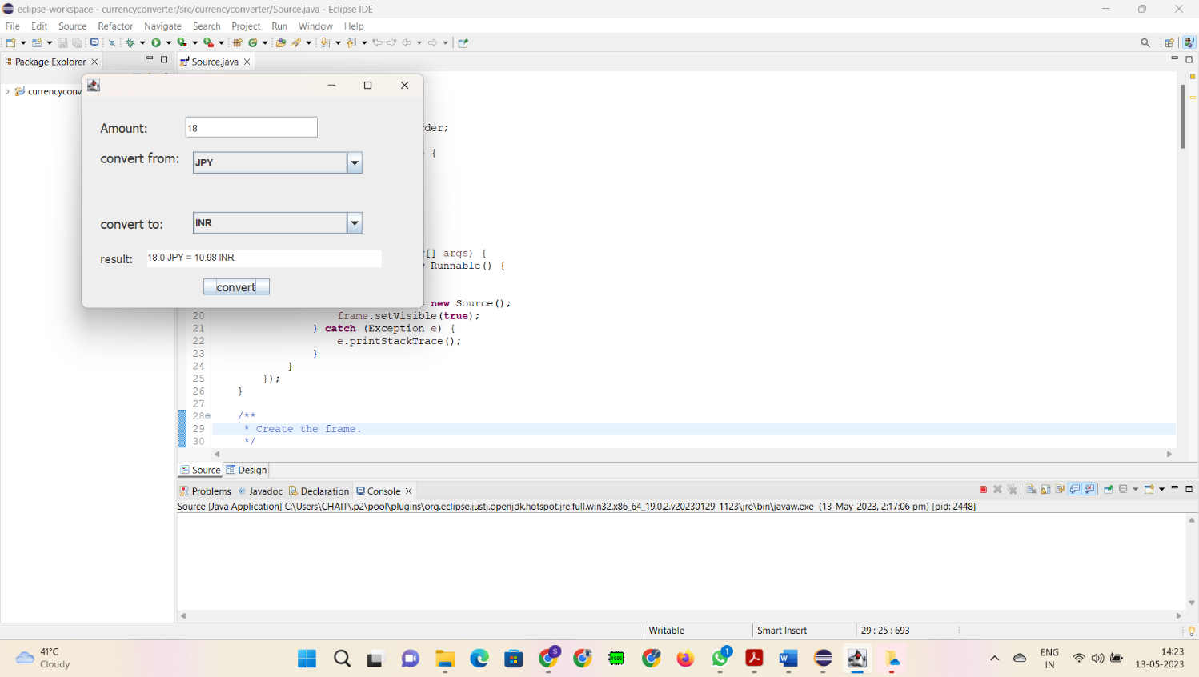 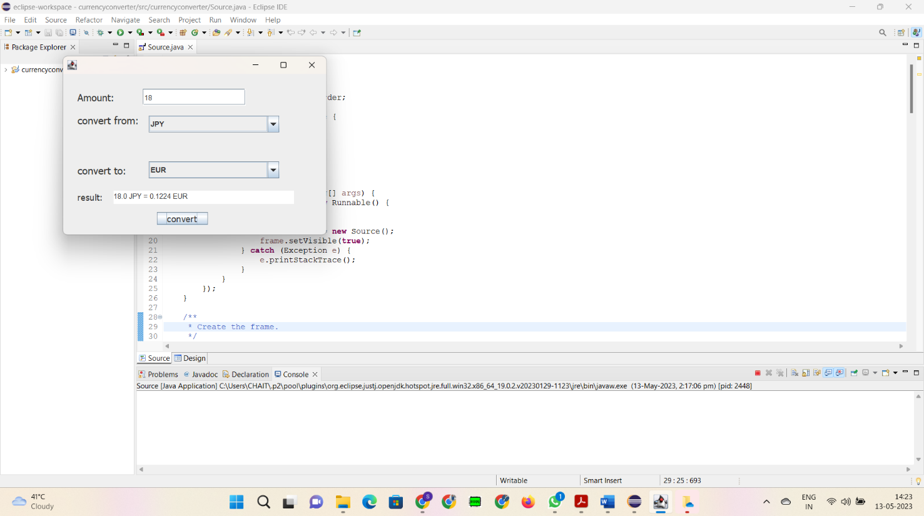

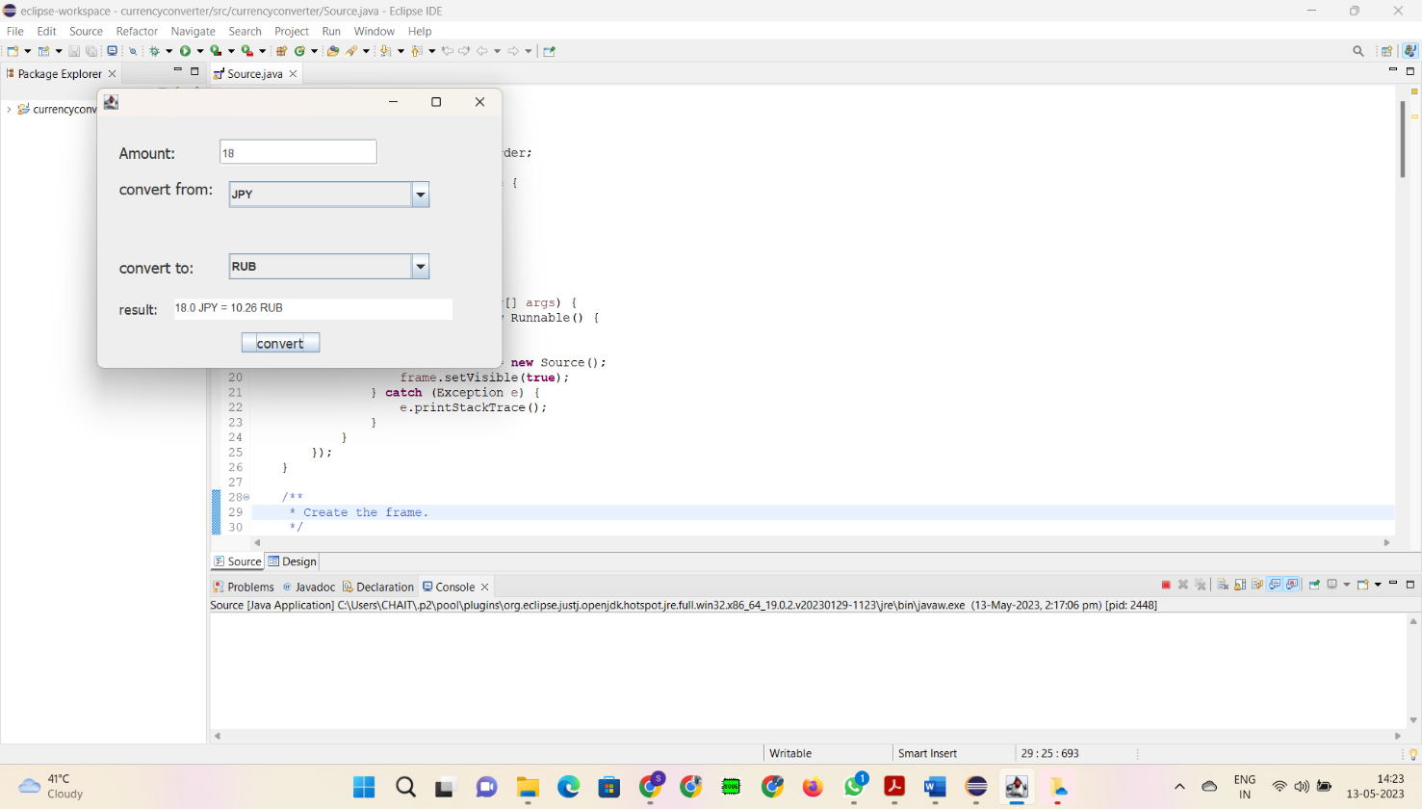 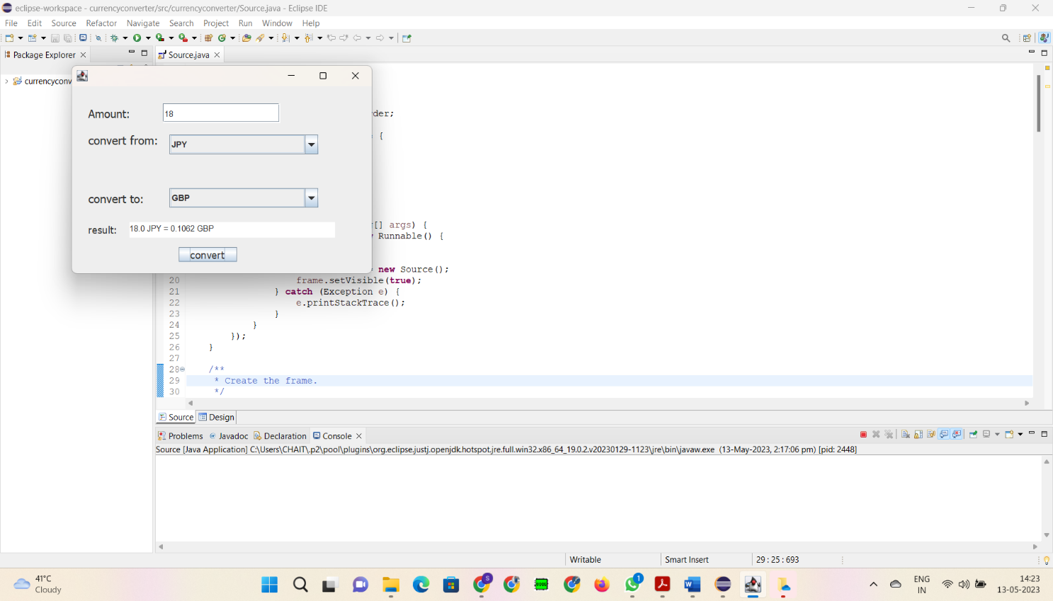 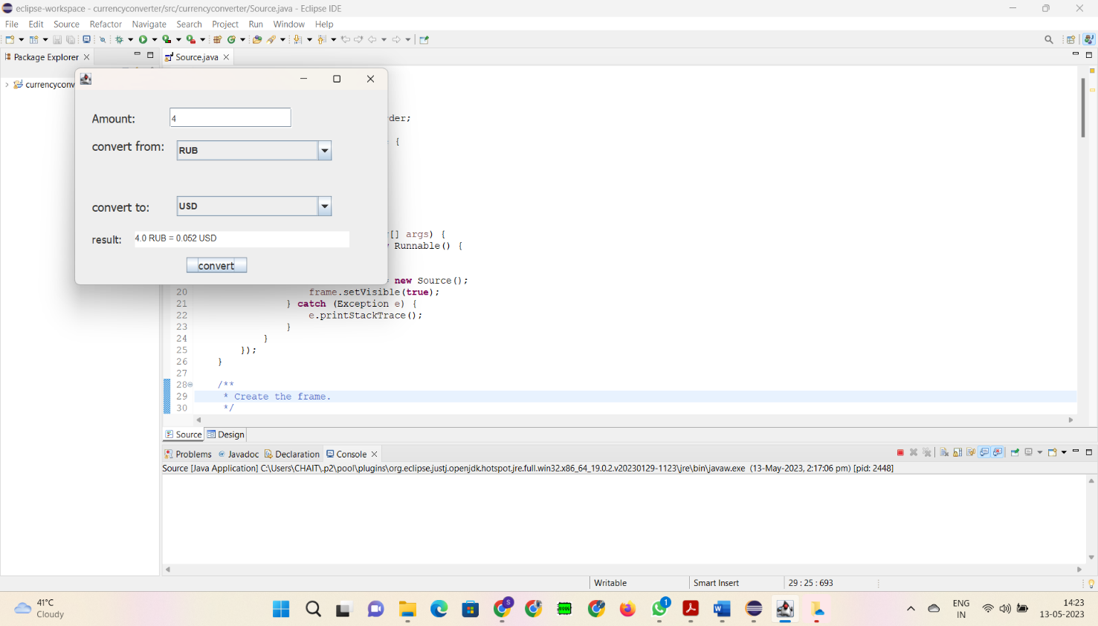

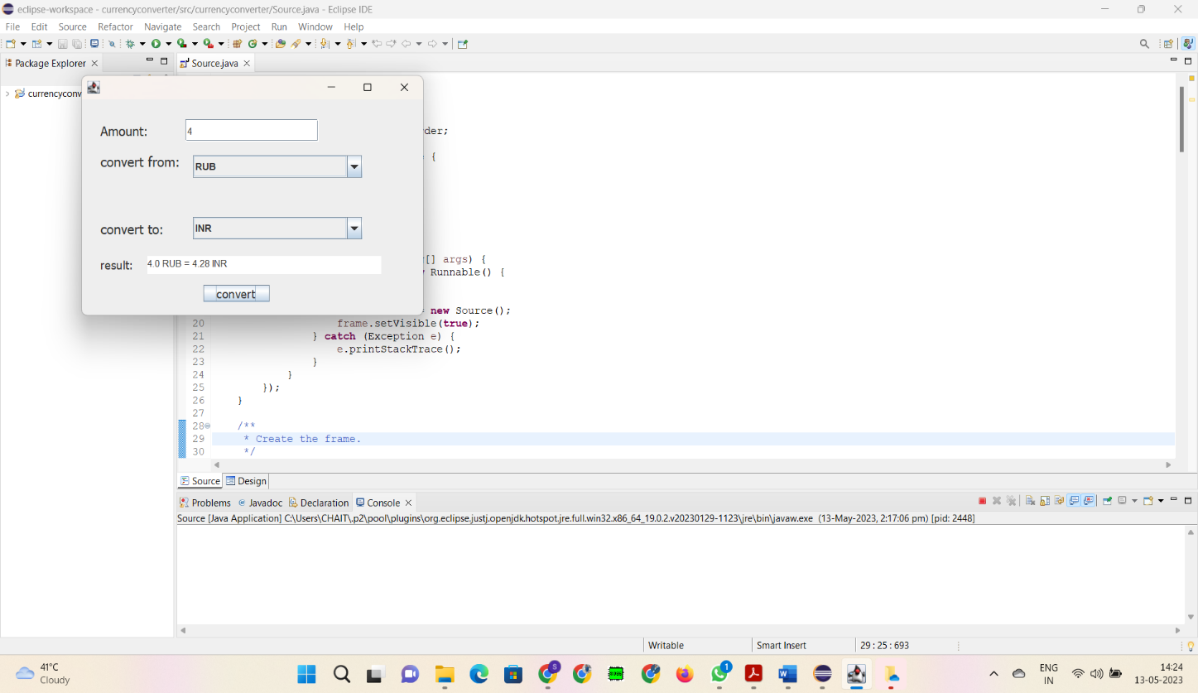 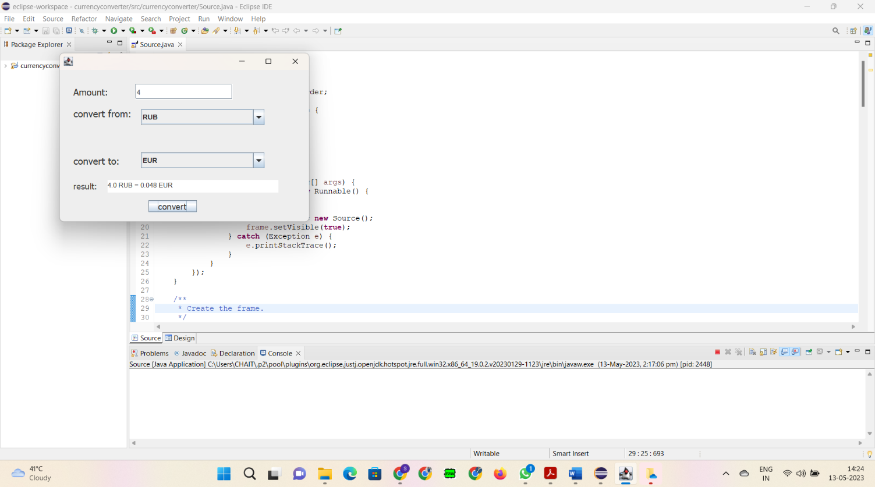 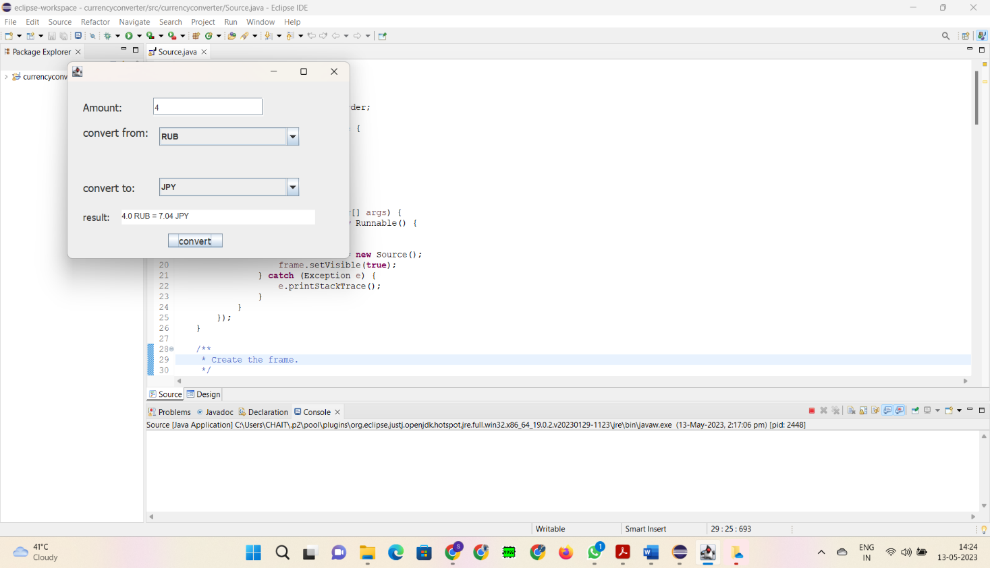

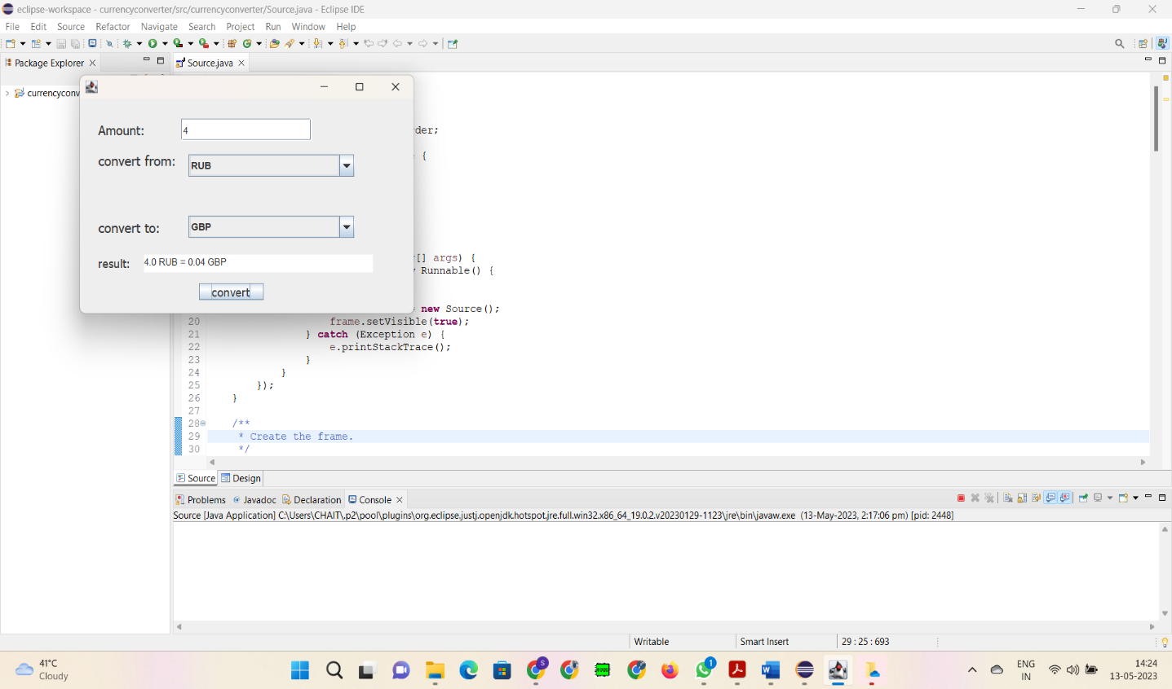 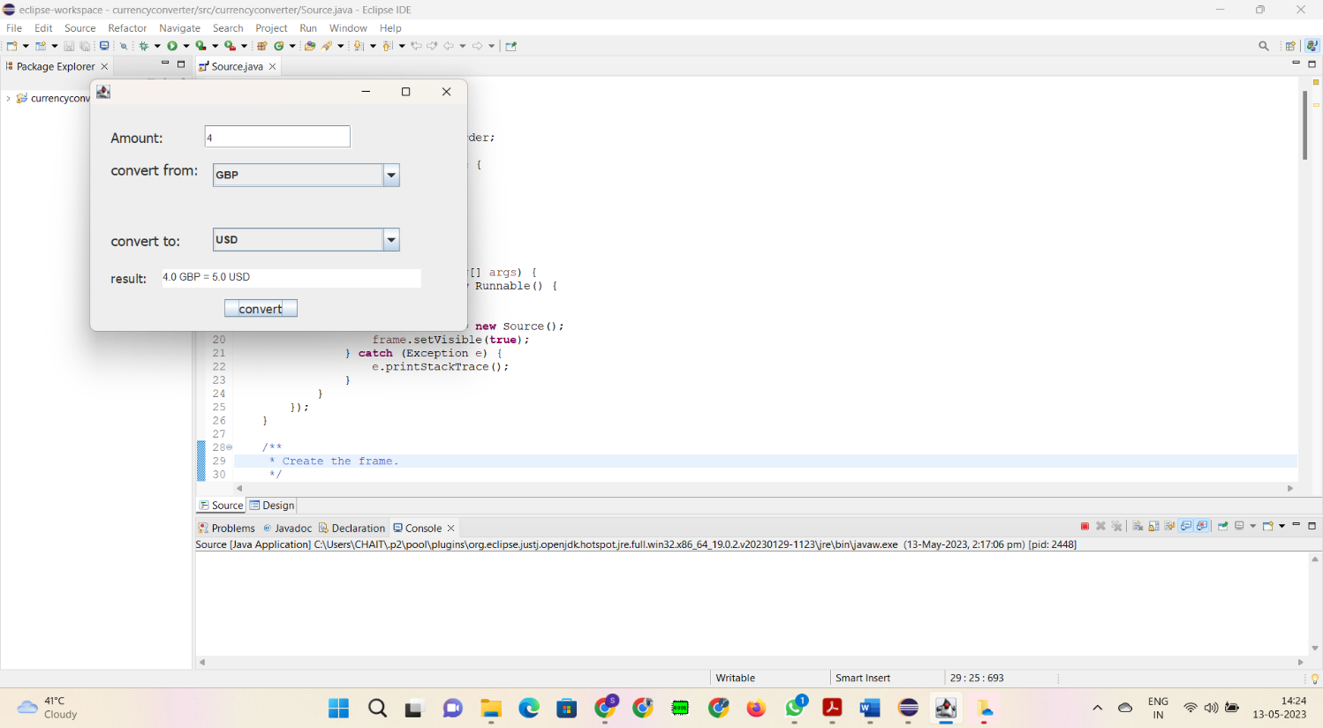 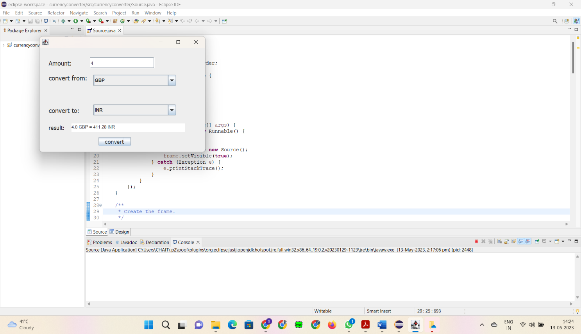

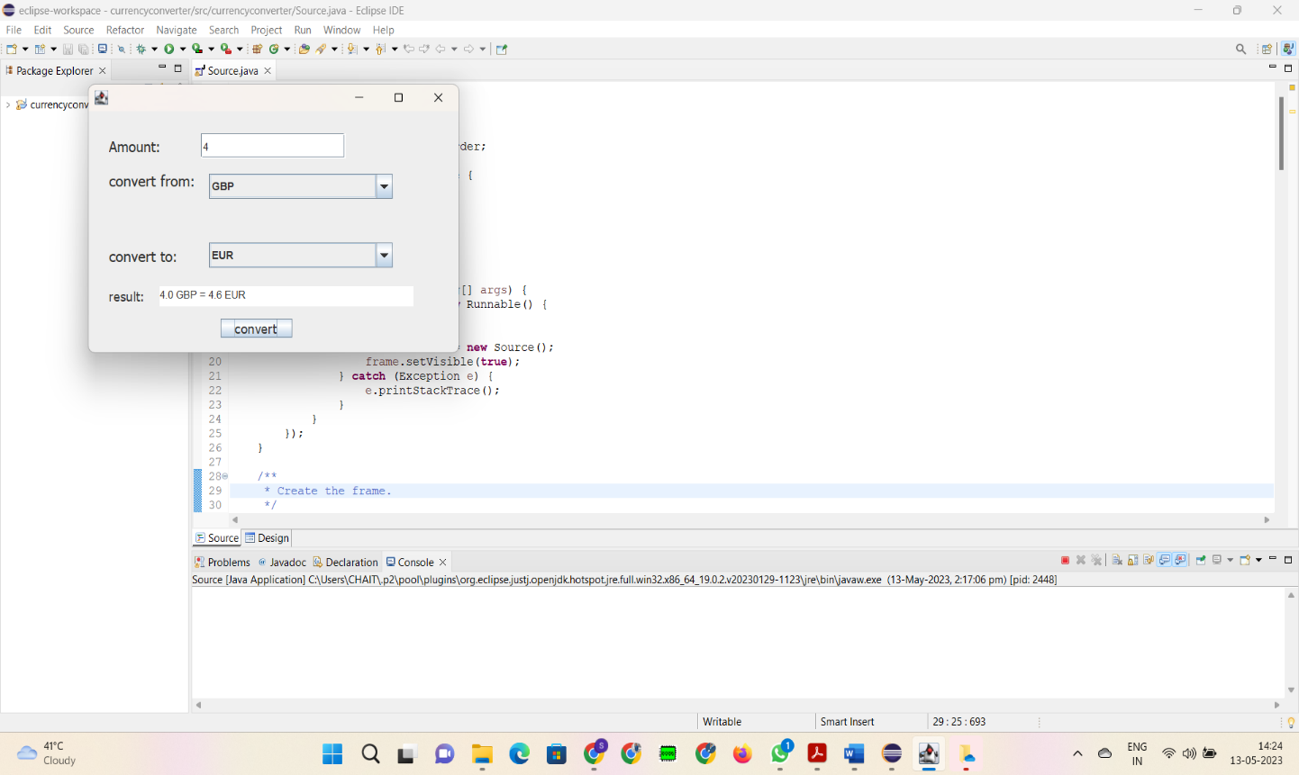 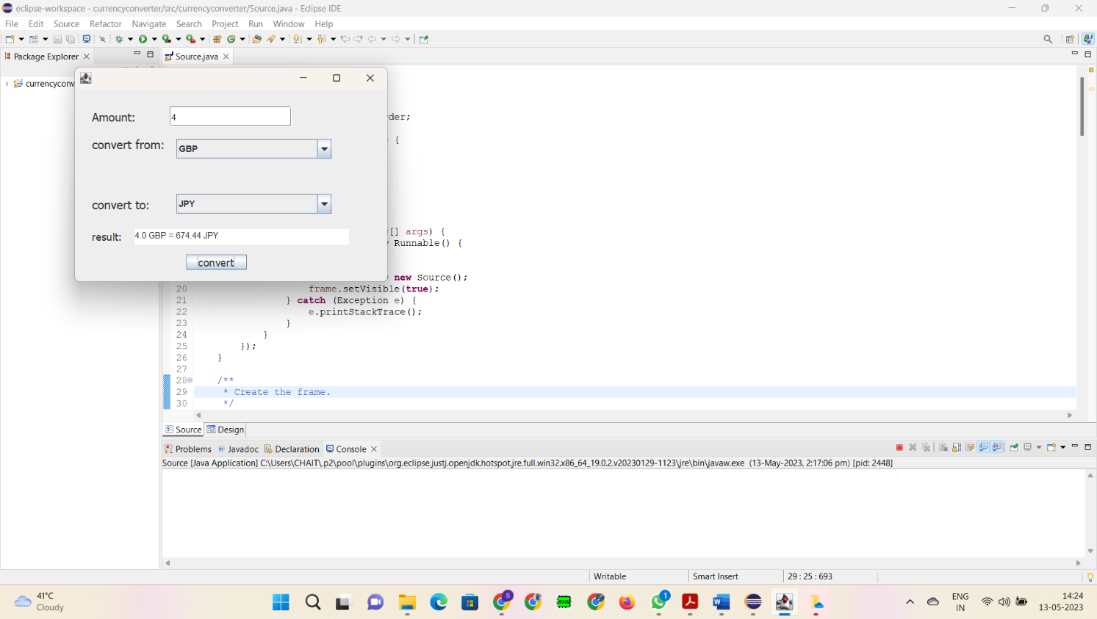 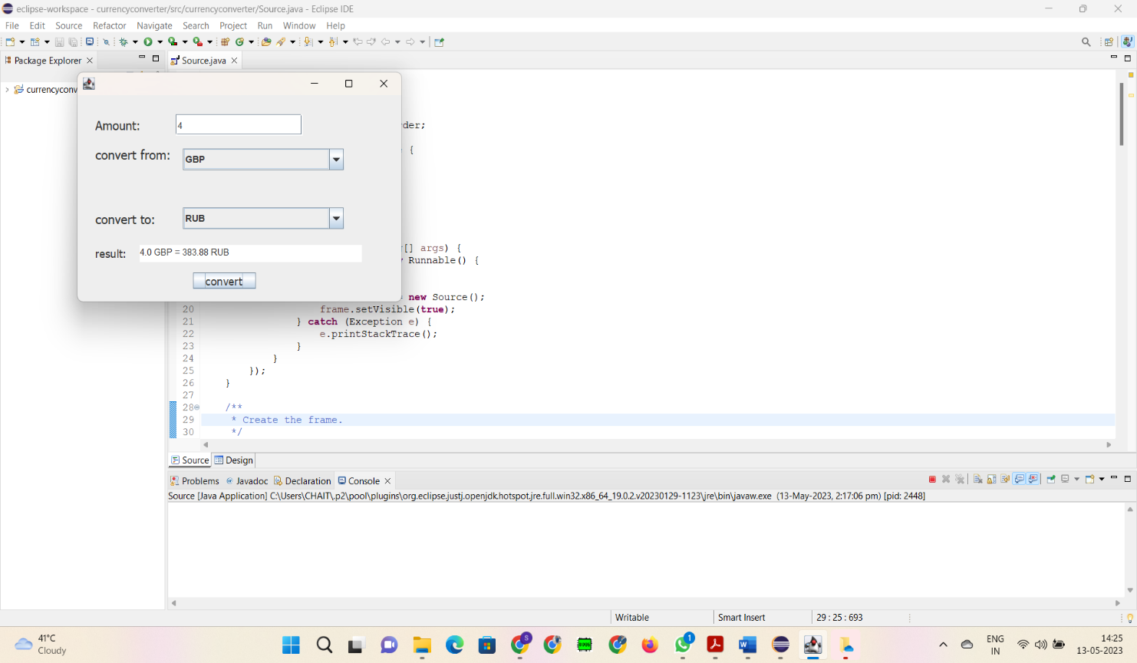

**CONCLUSION**

This is a currency converter program written in Java using GUI. The program provides a graphical user interface for the user to input an amount in a specific currency and convert it to another currency. The program fetches the exchange rate from a fixed set of exchange rates for different currency pairs and calculates the converted amount. The program converts between six currencies: USD, INR, EUR, JPY, RUB, and GBP.

Overall, this program provides basic currency conversion using java GUI.